0921 R Class 3

Dora Xu

2023-09-21

## R Markdown

## Level 1 heading

### Level 2 heading

#### Level 3 heading

summary(cars)

## speed dist   
## Min. : 4.0 Min. : 2.00   
## 1st Qu.:12.0 1st Qu.: 26.00   
## Median :15.0 Median : 36.00   
## Mean :15.4 Mean : 42.98   
## 3rd Qu.:19.0 3rd Qu.: 56.00   
## Max. :25.0 Max. :120.00

##Add code to your document

1+1

## [1] 2

1*9

## [1] 9

##Output figures

plot(1:10,1:10)

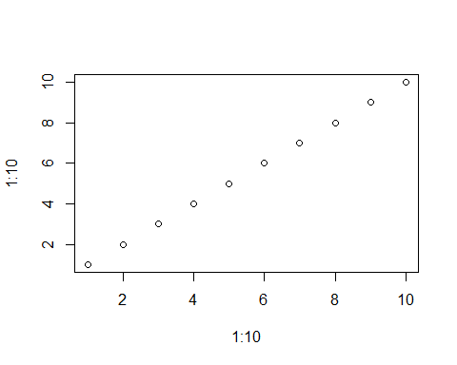

##Display Data

cars

## speed dist  
## 1 4 2  
## 2 4 10  
## 3 7 4  
## 4 7 22  
## 5 8 16  
## 6 9 10  
## 7 10 18  
## 8 10 26  
## 9 10 34  
## 10 11 17  
## 11 11 28  
## 12 12 14  
## 13 12 20  
## 14 12 24  
## 15 12 28  
## 16 13 26  
## 17 13 34  
## 18 13 34  
## 19 13 46  
## 20 14 26  
## 21 14 36  
## 22 14 60  
## 23 14 80  
## 24 15 20  
## 25 15 26  
## 26 15 54  
## 27 16 32  
## 28 16 40  
## 29 17 32  
## 30 17 40  
## 31 17 50  
## 32 18 42  
## 33 18 56  
## 34 18 76  
## 35 18 84  
## 36 19 36  
## 37 19 46  
## 38 19 68  
## 39 20 32  
## 40 20 48  
## 41 20 52  
## 42 20 56  
## 43 20 64  
## 44 22 66  
## 45 23 54  
## 46 24 70  
## 47 24 92  
## 48 24 93  
## 49 24 120  
## 50 25 85

##In-line R code (?) Scientific research shows that 12223 + 12111 = 2.3334^{4}

##How to insert code chunk quickly?

##Install tinytex

#install.packages("tinytex")  
#tinytex::install_tinytex()

##R markdown runs everything again!